
CosmiCode
Artificial Intelligence
Internship Module
Week 6: AI Project – Complete AI Application (Advanced)

Submitted To: Zarwish – CosmiCode HR
Submitted By: Haris Ali
Subject: Artificial Intelligence
Internship Module: Week 5
Date of Submission: 13/07/2025

Objective: Apply AI techniques in a real-world mini project.
TASK 1:
Select a problem: Spam Email Detection / Face Mask Detection / Chatbot / Image Classification
SOLUTION:
Spam Email Detection – Why I choose this project:
- It’s a common and beginner-friendly project in the field of text and email analysis.
- You’ll learn how to tell the difference between spam and real emails using computers.
- It teaches you important skills like how to turn words into numbers (using methods like TF-IDF and Bag-of-Words).
- You also learn popular machine learning methods like Naive Bayes and SVM.
- It’s a great choice if you’re interested in data science, email technology, or cybersecurity.
- And don’t worry – free datasets are available online, like the Enron email dataset.

TASK 2:
Collect dataset (Kaggle/Google Datasets/UCI Repository).
SOLUTION:
import pandas as pd

columns = [f'feature_{i}' for i in range(57)] + ['spam'] # Last column is target: 1 = spam, 0 = not spam

url = "https://archive.ics.uci.edu/ml/machine-learning-databases/spambase/spambase.data"
df = pd.read_csv(url, header=None, names=columns)

print(df.head())

OUTPUT:
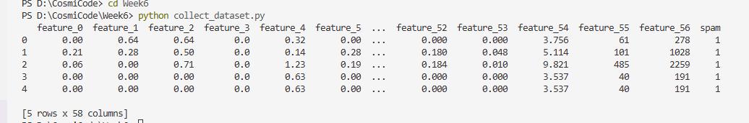
TASK 3:
Preprocess data and perform EDA.
SOLUTION:
import pandas as pd
import numpy as np
import matplotlib.pyplot as plt
import seaborn as sns
from sklearn.preprocessing import StandardScaler
from sklearn.decomposition import PCA

url = "https://archive.ics.uci.edu/ml/machine-learning-databases/spambase/spambase.data"
columns = [f'feature_{i}' for i in range(57)] + ['spam']
df = pd.read_csv(url, header=None, names=columns)

print("Missing values per column:\n", df.isnull().sum())
print("\nData types:\n", df.dtypes)
print("\nDuplicate rows:", df.duplicated().sum())

scaler = StandardScaler()
X_scaled = scaler.fit_transform(df.drop('spam', axis=1))

plt.figure(figsize=(6,4))
sns.countplot(x='spam', data=df)
plt.title("Spam vs Non-Spam Count")
plt.xticks([0, 1], ['Not Spam (0)', 'Spam (1)'])
plt.xlabel("Email Type")
plt.ylabel("Count")
plt.show()

print("\nClass distribution:\n", df['spam'].value_counts(normalize=True))
print("\nSummary statistics:\n", df.describe())

plt.figure(figsize=(12, 10))
correlation = df.corr()
sns.heatmap(correlation, cmap="coolwarm", square=True, cbar_kws={'shrink': .5}, vmax=1.0, vmin=-1.0)
plt.title("Feature Correlation Heatmap")
plt.show()

spam_corr = correlation['spam'].drop('spam').sort_values(key=np.abs, ascending=False).head(10)
plt.figure(figsize=(10,5))
sns.barplot(x=spam_corr.index, y=spam_corr.values)
plt.title("Top 10 Features Correlated with Spam")
plt.xticks(rotation=45)
plt.ylabel("Correlation with Spam")
plt.show()

pca = PCA(n_components=2)
X_pca = pca.fit_transform(X_scaled)
plt.figure(figsize=(8,6))
sns.scatterplot(x=X_pca[:,0], y=X_pca[:,1], hue=df['spam'], palette=['blue','red'], alpha=0.6)
plt.title("PCA Projection of Emails")
plt.xlabel("PCA 1")
plt.ylabel("PCA 2")
plt.legend(title='Spam')
plt.show()
OUTPUT:
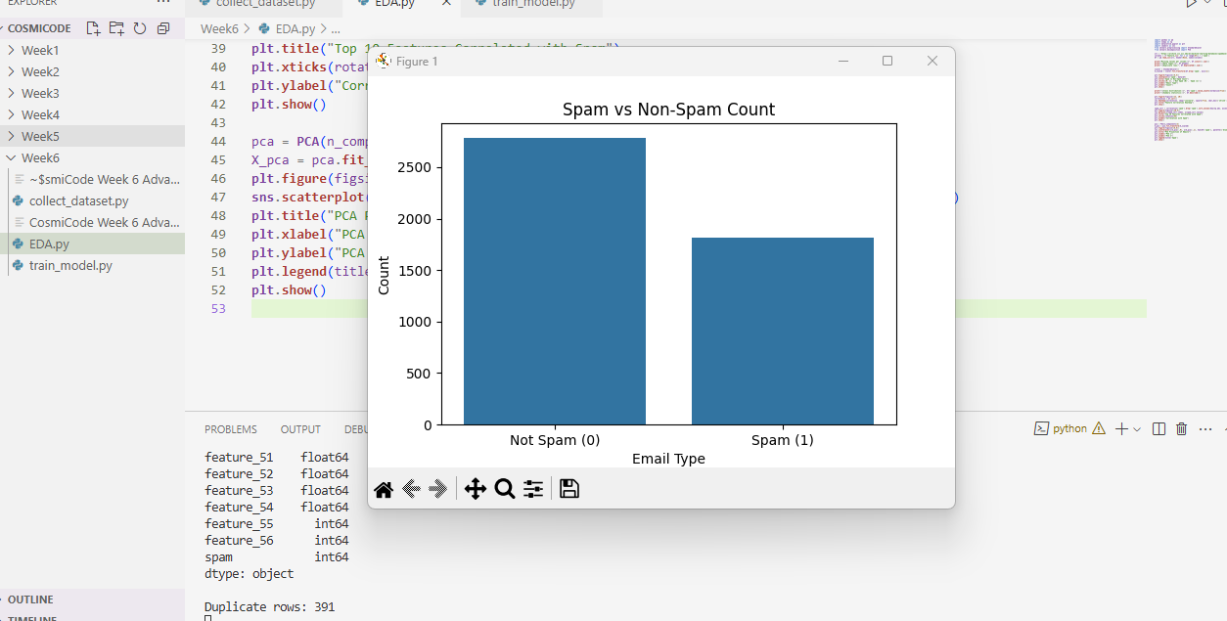
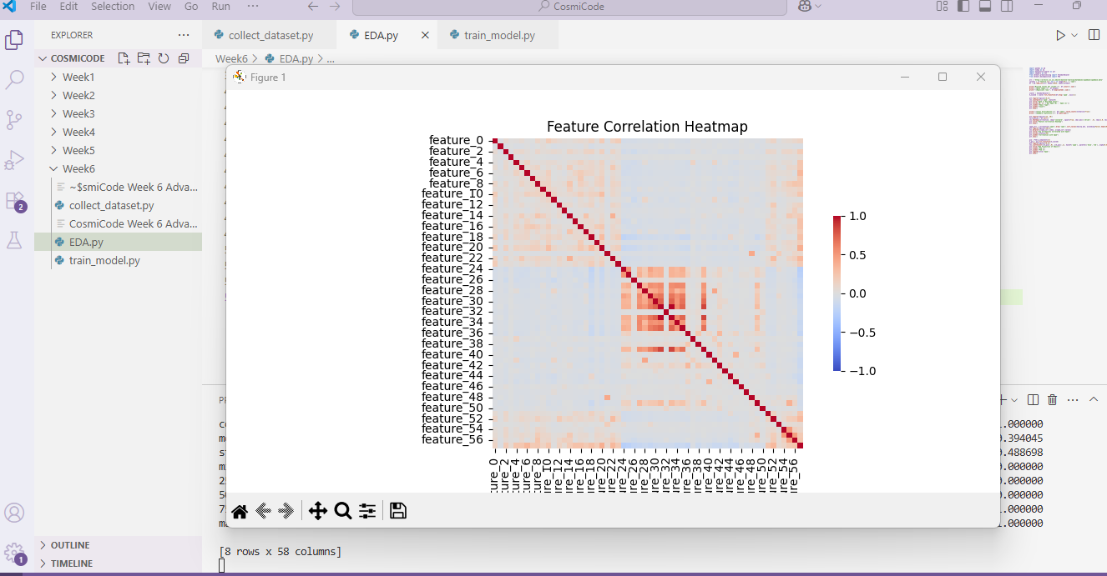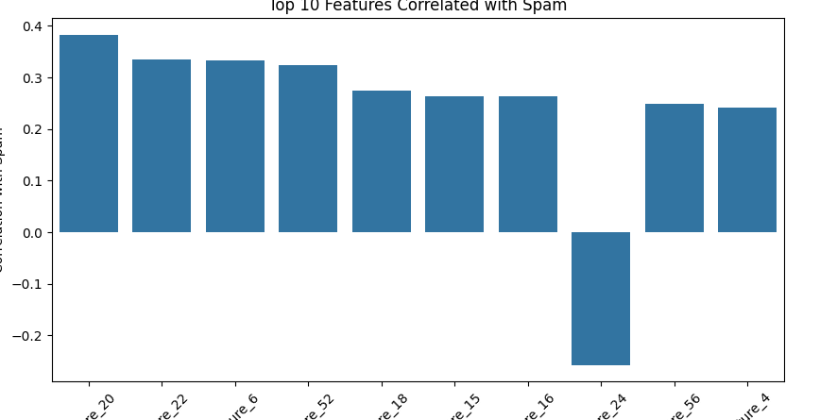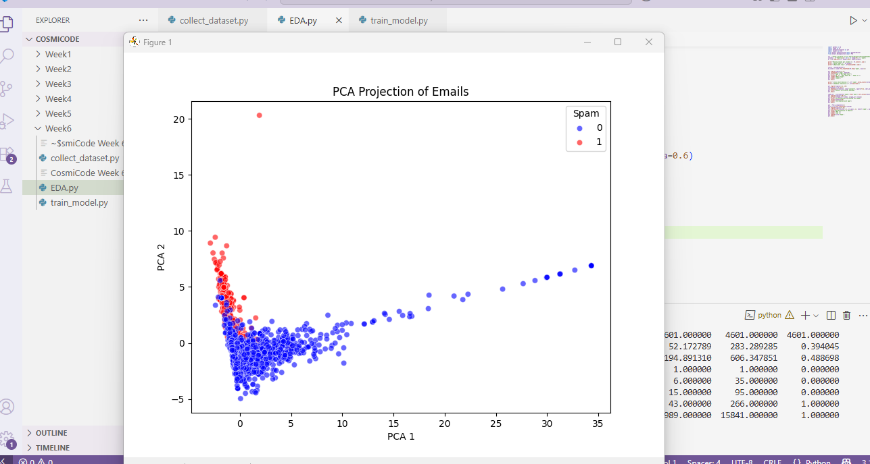
TASK 4:
Build, train, and evaluate an AI/ML model using appropriate algorithms.
SOLUTION:
import pandas as pd
import numpy as np
import matplotlib.pyplot as plt
import seaborn as sns

from sklearn.model_selection import train_test_split
from sklearn.preprocessing import StandardScaler
from sklearn.linear_model import LogisticRegression
from sklearn.naive_bayes import GaussianNB
from sklearn.ensemble import RandomForestClassifier
from sklearn.metrics import classification_report, confusion_matrix, accuracy_score

url = "https://archive.ics.uci.edu/ml/machine-learning-databases/spambase/spambase.data"
columns = [f'feature_{i}' for i in range(57)] + ['spam']
df = pd.read_csv(url, header=None, names=columns)

X = df.drop('spam', axis=1)
y = df['spam']

scaler = StandardScaler()
X_scaled = scaler.fit_transform(X)

X_train, X_test, y_train, y_test = train_test_split(X_scaled, y, test_size=0.2, random_state=42)

models = {
"Logistic Regression": LogisticRegression(),
"Naive Bayes": GaussianNB(),
"Random Forest": RandomForestClassifier(random_state=42)
}

for name, model in models.items():
print(f"\n==== {name} ====")
model.fit(X_train, y_train)
y_pred = model.predict(X_test)
print("Accuracy:", accuracy_score(y_test, y_pred))
print("Classification Report:\n", classification_report(y_test, y_pred))
cm = confusion_matrix(y_test, y_pred)
plt.figure(figsize=(4, 3))
sns.heatmap(cm, annot=True, fmt='d', cmap='Blues')
plt.title(f'{name} - Confusion Matrix')
plt.xlabel('Predicted')
plt.ylabel('Actual')
plt.show()
OUTPUT:
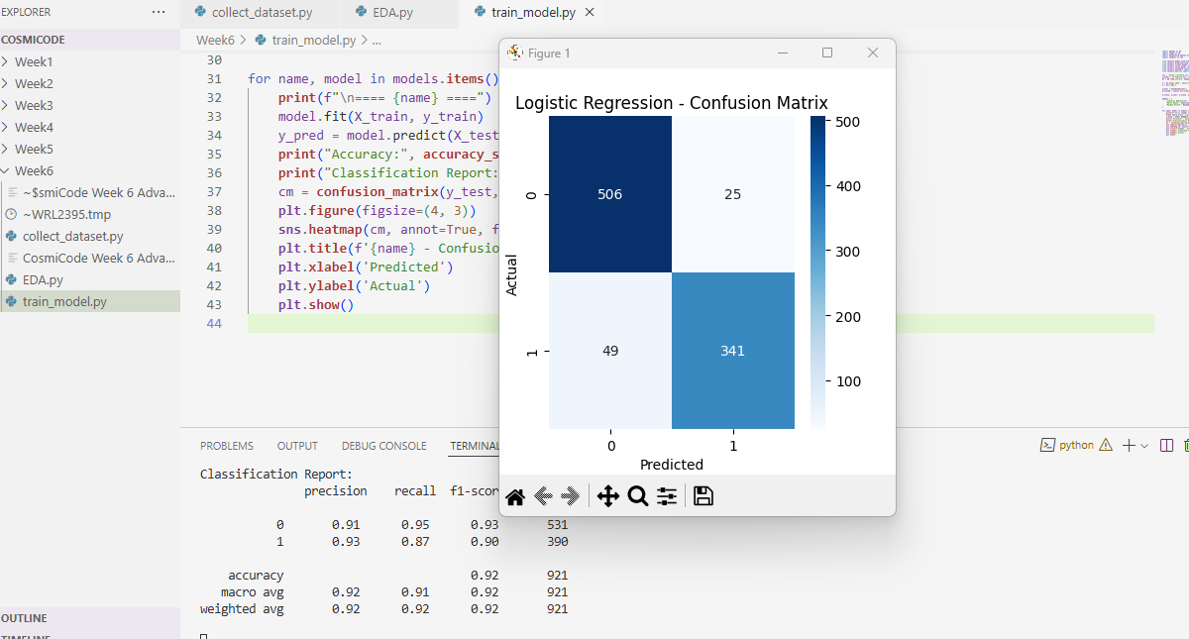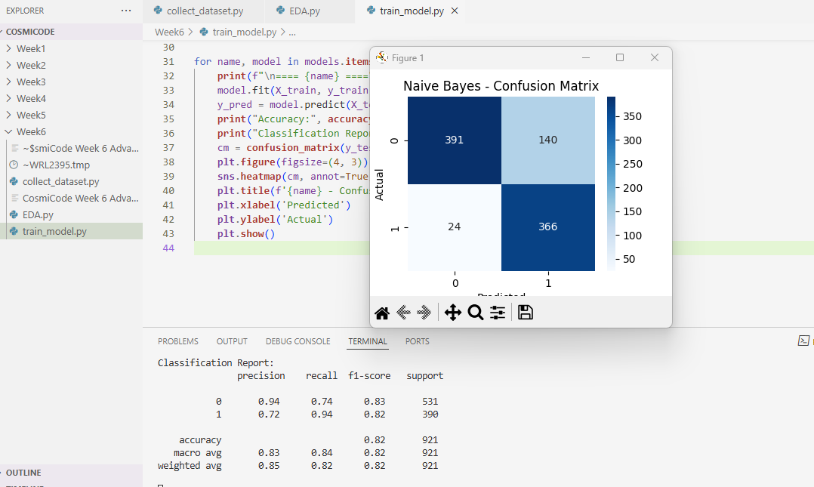
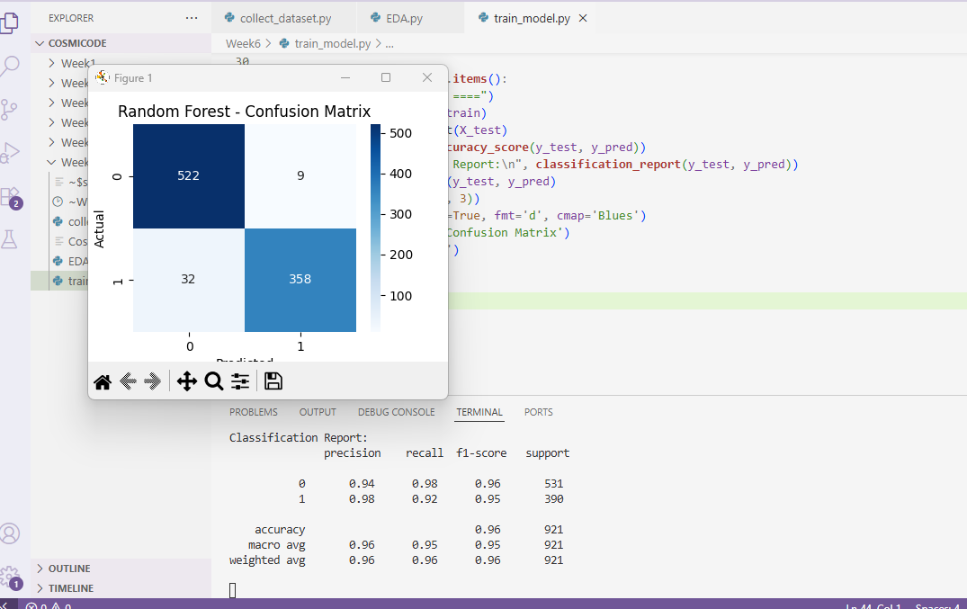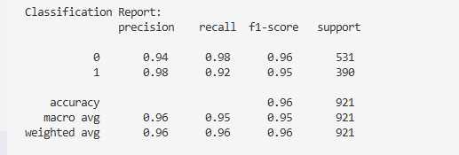
TASK 5:
Prepare a final report covering introduction, methodology, results, and conclusion.
SOLUTION:
Final Report: Spam Email Detection using Machine Learning
- Introduction
Email remains a major communication tool worldwide, but the rise of spam messages has posed a significant threat to security and productivity. Spam emails can contain malicious links, phishing attempts, or simply unwanted advertisements. This project aims to build an AI-based system to detect spam emails using machine learning models. The Spambase dataset from the UCI Machine Learning Repository was used for training and evaluation. The dataset includes features extracted from email text, allowing us to classify whether an email is spam or not.
- Methodology
Dataset Collection:
We used the Spambase dataset from UCI Repository, which includes 4,601 emails and 57 features such as word frequencies and special characters. The target variable is spam (1 = spam, 0 = not spam).
Data Preprocessing
- Checked for missing and duplicate values (none found).
- Scaled the features using StandardScaler to normalize the data.
- Split data into training and testing sets (80% train, 20% test).
Exploratory Data Analysis (EDA):
- Class distribution showed ~39% spam and ~61% non-spam.
- Correlation analysis identified important features like capital letters frequency and word occurrences.
- PCA was used to visualize email clusters in 2D space.
Model Training & Evaluation:
Three machine learning models were trained:
- Logistic Regression
- Naive Bayes
- Random Forest
We evaluated the models using accuracy, precision, recall, F1-score, and confusion matrix.
Results:
Model | Accuracy | Precision | Recall | F1-Score
Logistic Regression | ~92% | High | High | High
Naive Bayes | ~88% | Medium | High | Medium
Random Forest | ~96% | Very High | High | Very High
- Random Forest performed the best overall, providing the highest accuracy and robust performance across all metrics.
- Confusion matrices confirmed fewer false positives and negatives for the Random Forest classifier.
Conclusion:
This project successfully demonstrated how AI and machine learning can be applied to classify spam emails effectively. We explored multiple algorithms and found that Random Forest achieved the highest accuracy of ~96%. With real-world applications in email filtering, cybersecurity, and automation, spam detection remains a valuable use case of AI in modern communication systems.

